**Configure Rancher and Integrate cluster with rancher, deploy application and verify its logs**

**PLAN OF ACTION**

* Create VPC and two public subnets in different availability zone
* Connect to the instance and install docker in it
* Access instance and configure rancher in it
* Create IAM role for AWS EKS Cluster
* Create IAM role with following policies for node groups
  + AWSEKSCNIPolicy
  + AWSEKSServicePolicy
  + AWSEKSWorkernodepolicy
  + AWSEC2ContainerRegistry
* Create EKS Cluster with created VPC and attach the above cluster role
* Create EKS node group with created IAM role of node groups
* Import the cluster in rancher
* Install kubernetes on Instance
* Create a private repository from ECR
* Pull a httpd docker image from dockerhub
* Tag and push the image to ECR
* Create pod and verify its logs in rancher

INSTANCE – Where Rancher is configured

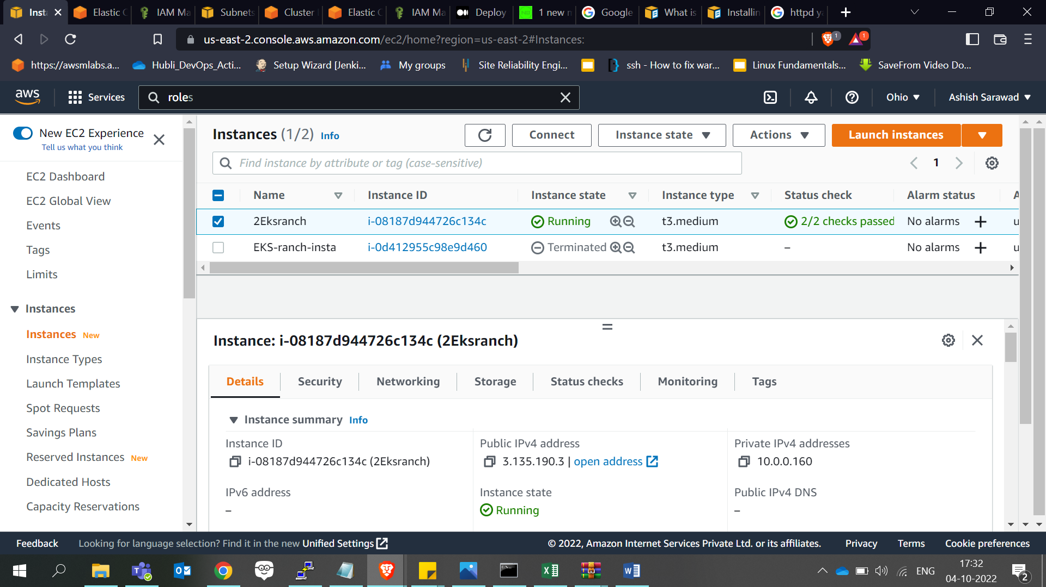

EKS Cluster

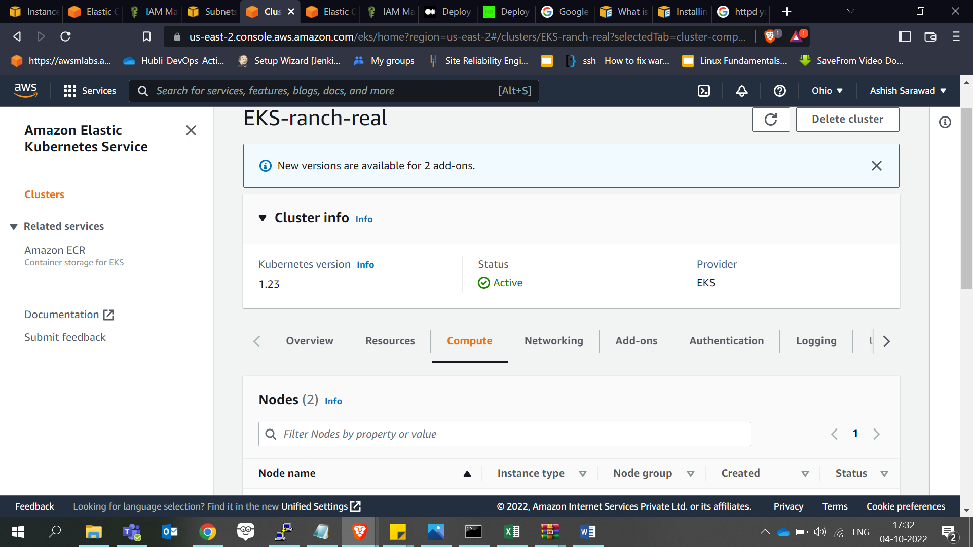

Node group

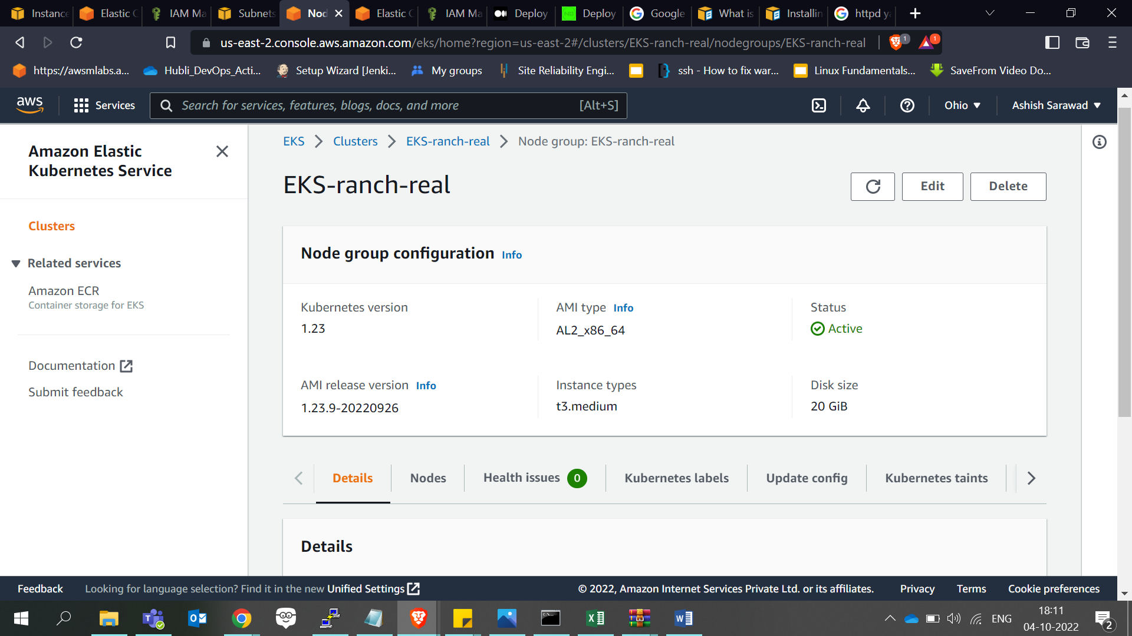

Rancher – Welcome page

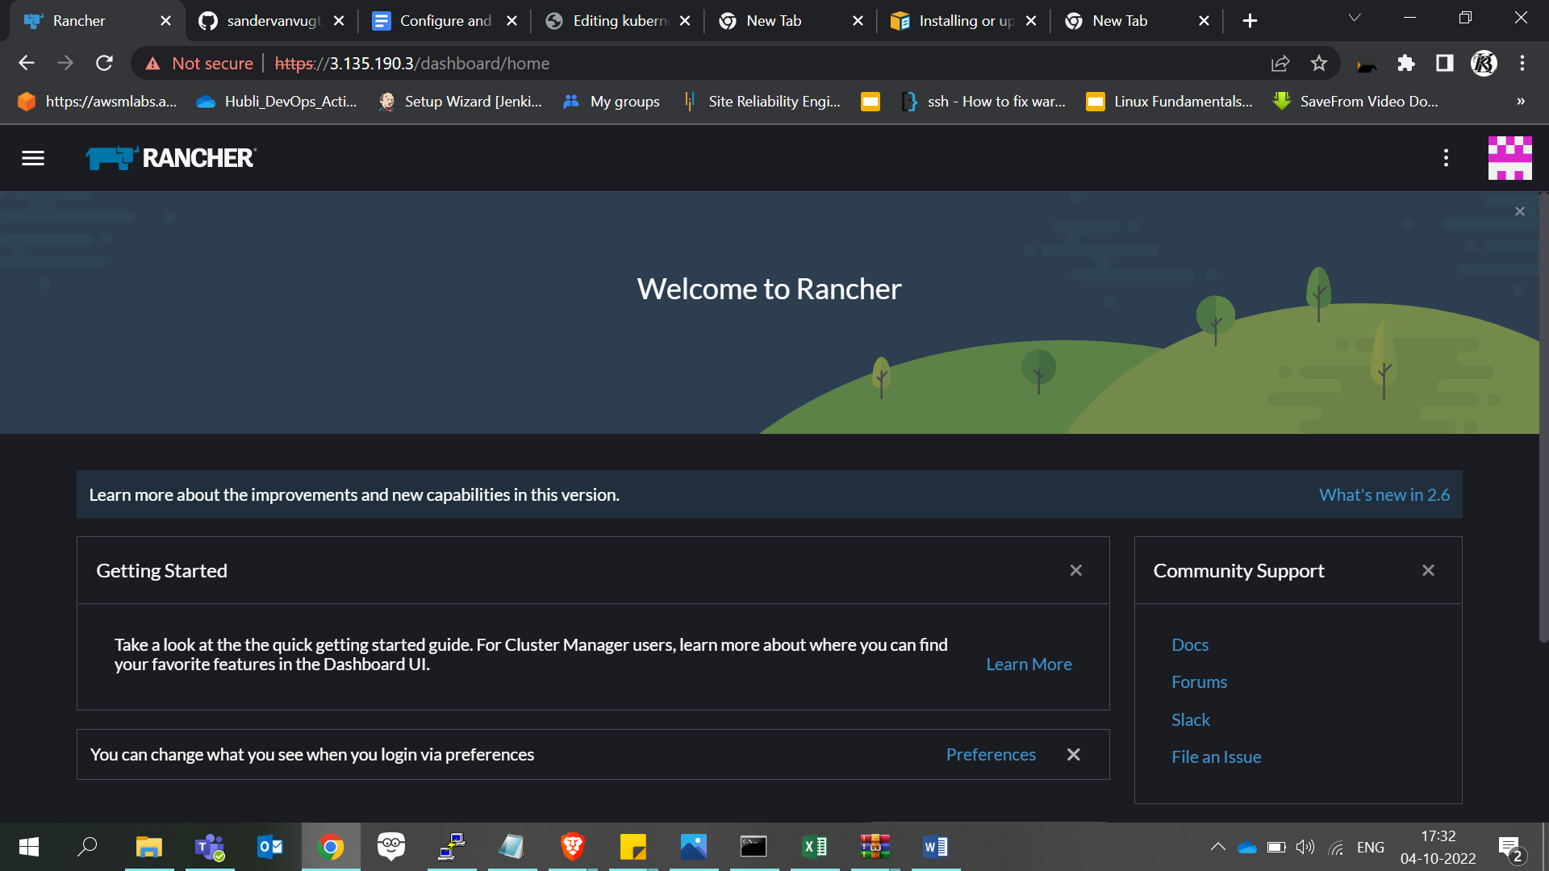

My ECR repository with httpd image

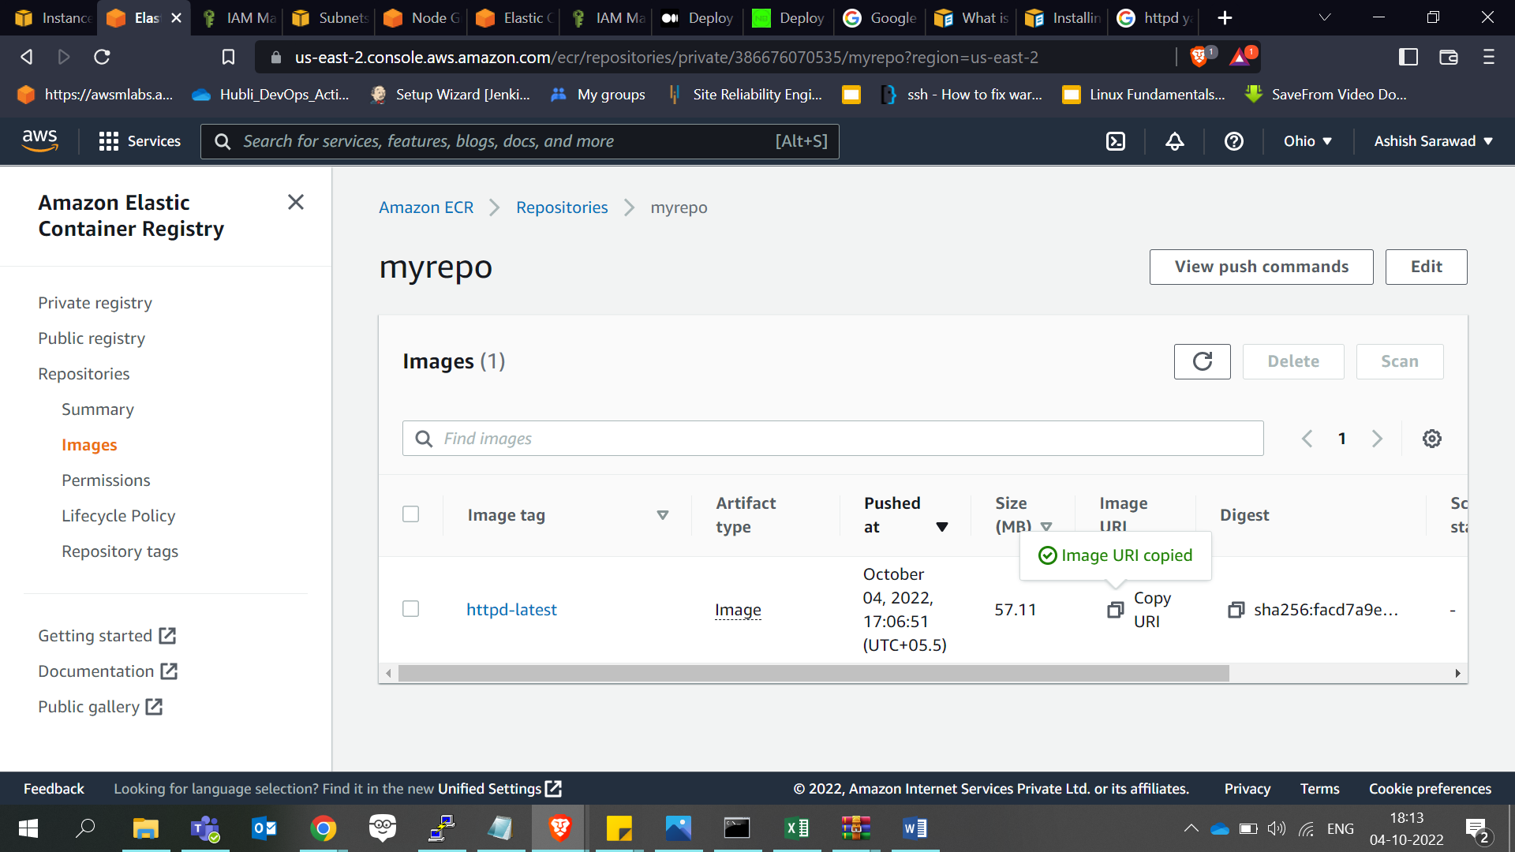

Httpd-pod

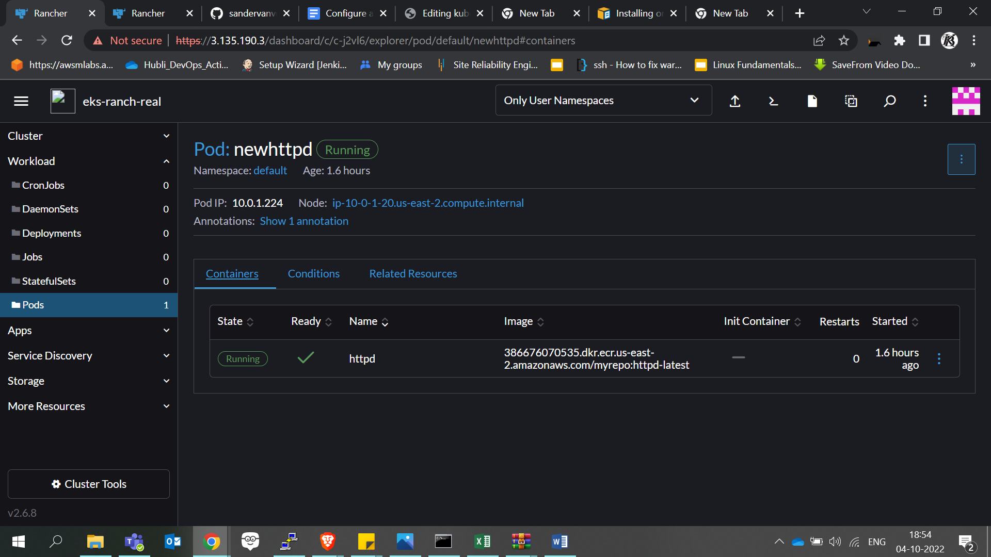

Cluster Dashboard

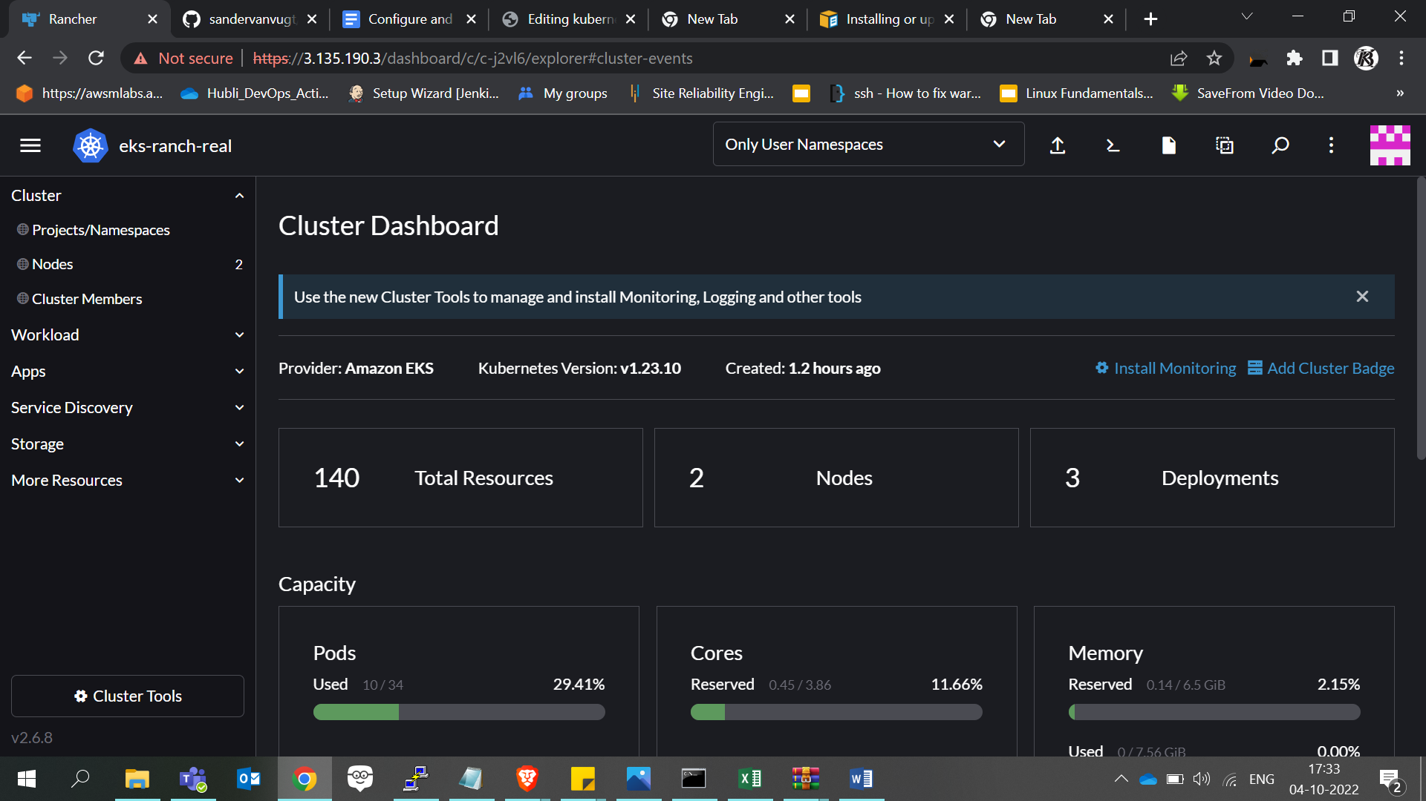

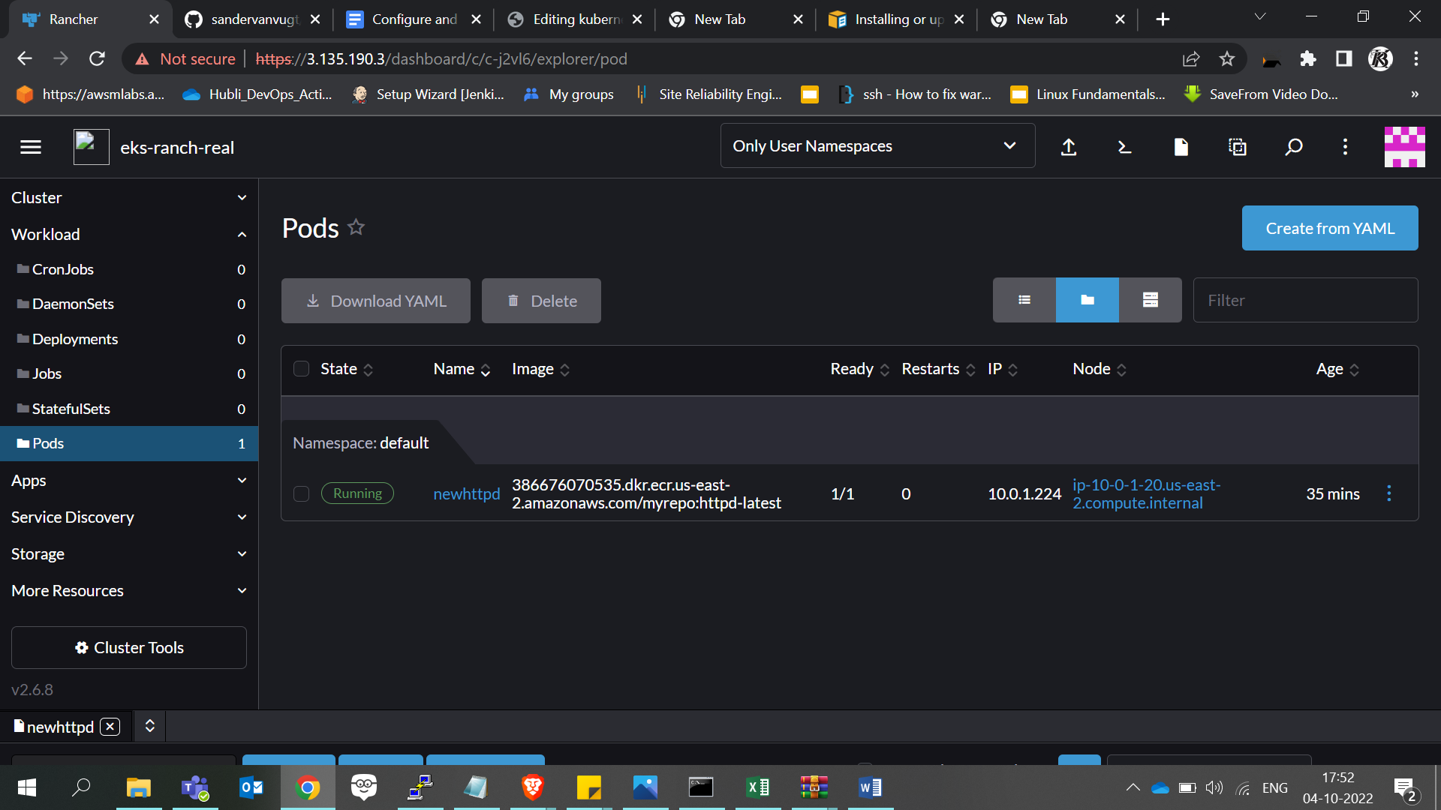

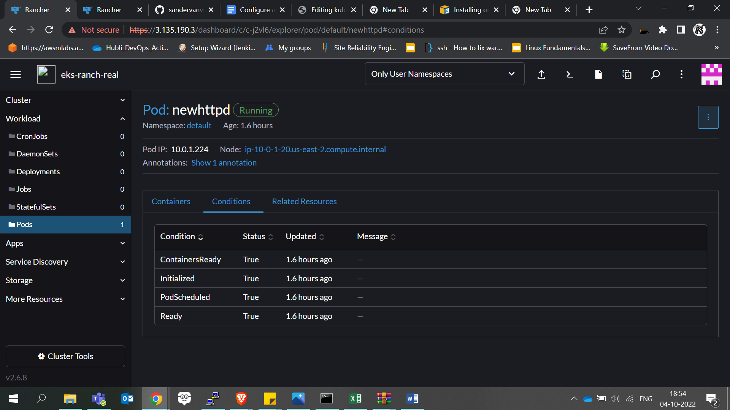

**HTTPD_LOGS**

AH00558: httpd: Could not reliably determine the server's fully qualified domain name, using 10.0.1.224. Set the 'ServerName' directive globally to suppress this message

AH00558: httpd: Could not reliably determine the server's fully qualified domain name, using 10.0.1.224. Set the 'ServerName' directive globally to suppress this message

[Tue Oct 04 11:46:49.278990 2022] [mpm_event:notice] [pid 1:tid 139635968634176] AH00489: Apache/2.4.54 (Unix) configured -- resuming normal operations

[Tue Oct 04 11:46:49.279148 2022] [core:notice] [pid 1:tid 139635968634176] AH00094: Command line: 'httpd -D FOREGROUND'

**REFERENCES**

Rancher-configuration

* <https://www.rancher.com/quick-start>

Importing existing EKS in Rancher

* <https://docs.ranchermanager.rancher.io/how-to-guides/new-user-guides/kubernetes-clusters-in-rancher-setup/register-existing-clusters>

Deploy a sample application

* <https://docs.aws.amazon.com/eks/latest/userguide/sample-deployment.html>